Patty Cook (Anna Simon’s mom’s) AMAZING Carrot Kugel

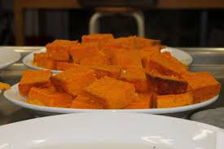

3 lbs. carrots – steamed and mashed
6 eggs
1½ C sugar
9 T flour or cake meal
3 t baking powder
3 t vanilla
¼ t cinnamon
2 t salt
1 t lemon juice
1 stick melted margarine

Preheat oven to 350 degrees
Mix all ingredients with an electric mixer and pour into greased 9x13 casserole.
Bake one hour and check. Bake 15 more minutes if needed. Do not overbake.

