- Choosing Your Child’s B’nai Mitzvah Date  Please keep this in mind when choosing your child’s date:  We make every effort to assign a date within one month either side of their thirteenth birthday. Not sure of your child’s Hebrew birthday? Go to HebCal, click on the date converter table and type in the birthdate. Yes! It is THAT easy.  If you know now your family has a date conflict (i.e. graduation, wedding, reunion), please indicate the date(s) on the form.  Look at the side bar of this document for important dates when the holidays are celebrated and/or the building is not available for evening celebrations. Just a reminder: all Jewish holidays begin at sunset the day before. To read/learn about a specific Torah portion or holiday, please click here.  We will do our best to work with you to find a date that meets your family’s needs.  We look forward to celebrating this milestone with you and your family.  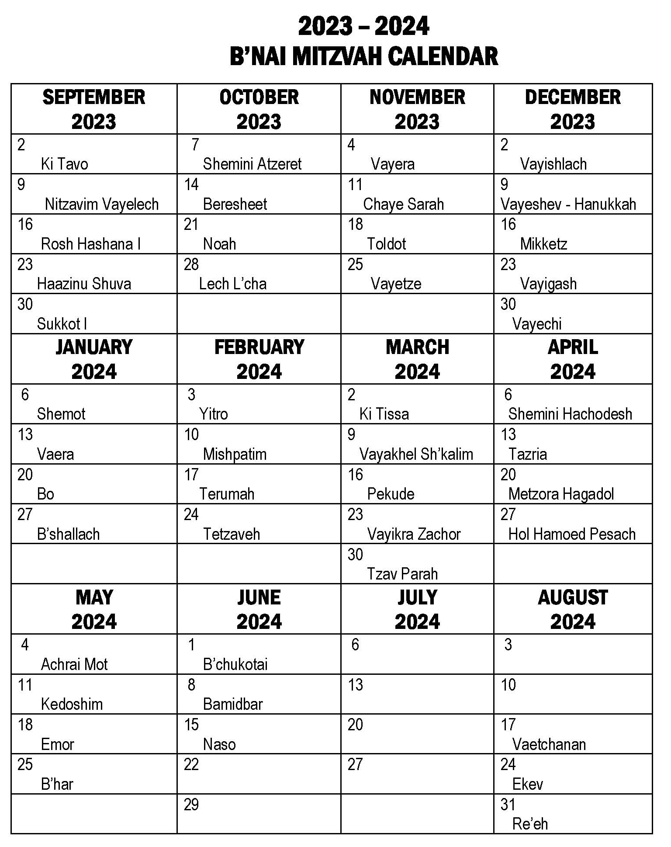 | Dates to Keep in Mind  September 2023  Labor Day:  Monday, September 4  Selichot:  Saturday, September 9  – No Evening Party  Rosh Hashana:  Saturday & Sunday, September 16 & 17  Yom Kippur:  Monday, September 25  Sukkot:  Saturday, September 30  October 2023  Sukkot:  Sunday, October 1  Shemini Atzeret:  Saturday, October 7  Simchat Torah:  Sunday, October 8  MEA Weekend:  Thursday & Friday, October 17 & 18  November 2023  Thanksgiving:  Thursday, November 23  December 2023  Hanukkah:  Friday, December 8 – Friday, December 15  Christmas:  Sunday, December 25  January 2024  New Year’s Day  Sunday, January 1  Martin Luther King Day:  Monday, January 15  Tu B’shevat  Thursday, January 25  February 2024  Presidents’ Day  Monday, February 19  March 2024  Purim  Sunday, March 24  ** Saturday, March 23 – No Evening Party*  April 2024  Passover  Tiuesday, April 23 – Thursday, April 30  MAY 2024  Sunday, May 12  Lag B’omer:  Sunday, May 26  Memorial Day:  Monday, May 27  JUNE 2024  Shavuot  Wednesday & Thursday, June 12 & 13  Father’s Day  Sunday, June 16  SEPTEMBER 2024  Labor Day  Monday, September 2

